Roll No-12

M.sc. 3rd semester

Date of Assignment-08/12/2020

Date of Submission-14/12/2020

**Experiment No -10**

**Topic**- Calculation of Auto covariance and Auto correlation function for time series analysis

**Problem** – Following are the temperature measurements made on a chemical reactor every minute. Calculate the Auto covariance and Auto correlation function up to lag 5.

**Temperature-**200,202,208,204,202,201,200,199,201,198,200,203,201,211,204,206,203,203,204,207,206,207, 206,207,206,200,207,205,200,195,202, 204,203,198,200.

**Theory and Calculation**-

The auto-covariance at lag k is given by-



 -----(1)

We know for a stationary time series -

 ------(a)

------(b)

Therefore, equation (1) becomes-

 ------(2)

And the auto-correlation function at lag k is given by-



 {Using eqn(a) and eqn (b) and eqn (2)}



{ The above formula can be apply only for population values }

The sample estimate of Rk i.e. the sample auto-covariance function at lag k is given by-



And the sample auto-correlation function at lag k is given by-

 Where, 

**Calculation-**

For lag 1, we construct the following table-

|  |  |  |  |  |  |  |
| --- | --- | --- | --- | --- | --- | --- |
| t |  |  |  |  |  |  |
| 1 | 200 | 202 | -2.757575758 | -0.757575758 | 2.089072544 | 7.604224059 |
| 2 | 202 | 208 | -0.757575758 | 5.242424242 | -3.971533517 | 0.573921028 |
| 3 | 208 | 204 | 5.242424242 | 1.242424242 | 6.513314968 | 27.48301194 |
| 4 | 204 | 202 | 1.242424242 | -0.757575758 | -0.941230487 | 1.543617998 |
| 5 | 202 | 201 | -0.757575758 | -1.757575758 | 1.331496786 | 0.573921028 |
| 6 | 201 | 200 | -1.757575758 | -2.757575758 | 4.846648301 | 3.089072544 |
| 7 | 200 | 199 | -2.757575758 | -3.757575758 | 10.36179982 | 7.604224059 |
| 8 | 199 | 201 | -3.757575758 | -1.757575758 | 6.604224059 | 14.11937557 |
| 9 | 201 | 198 | -1.757575758 | -4.757575758 | 8.361799816 | 3.089072544 |
| 10 | 198 | 200 | -4.757575758 | -2.757575758 | 13.11937557 | 22.63452709 |
| 11 | 200 | 203 | -2.757575758 | 0.242424242 | -0.668503214 | 7.604224059 |
| 12 | 203 | 202 | 0.242424242 | -0.757575758 | -0.183654729 | 0.058769513 |
| 13 | 202 | 211 | -0.757575758 | 8.242424242 | -6.24426079 | 0.573921028 |
| 14 | 211 | 204 | 8.242424242 | 1.242424242 | 10.2405877 | 67.93755739 |
| 15 | 204 | 206 | 1.242424242 | 3.242424242 | 4.028466483 | 1.543617998 |
| 16 | 206 | 203 | 3.242424242 | 0.242424242 | 0.786042241 | 10.51331497 |
| 17 | 203 | 203 | 0.242424242 | 0.242424242 | 0.058769513 | 0.058769513 |
| 18 | 203 | 204 | 0.242424242 | 1.242424242 | 0.301193756 | 0.058769513 |
| 19 | 204 | 207 | 1.242424242 | 4.242424242 | 5.270890725 | 1.543617998 |
| 20 | 207 | 206 | 4.242424242 | 3.242424242 | 13.75573921 | 17.99816345 |
| 21 | 206 | 207 | 3.242424242 | 4.242424242 | 13.75573921 | 10.51331497 |
| 22 | 207 | 206 | 4.242424242 | 3.242424242 | 13.75573921 | 17.99816345 |
| 23 | 206 | 200 | 3.242424242 | -2.757575758 | -8.941230487 | 10.51331497 |
| 24 | 200 | 207 | -2.757575758 | 4.242424242 | -11.69880624 | 7.604224059 |
| 25 | 207 | 205 | 4.242424242 | 2.242424242 | 9.513314968 | 17.99816345 |
| 26 | 205 | 200 | 2.242424242 | -2.757575758 | -6.183654729 | 5.028466483 |
| 27 | 200 | 195 | -2.757575758 | -7.757575758 | 21.39210285 | 7.604224059 |
| 28 | 195 | 202 | -7.757575758 | -0.757575758 | 5.876951331 | 60.17998163 |
| 29 | 202 | 204 | -0.757575758 | 1.242424242 | -0.941230487 | 0.573921028 |
| 30 | 204 | 203 | 1.242424242 | 0.242424242 | 0.301193756 | 1.543617998 |
| 31 | 203 | 198 | 0.242424242 | -4.757575758 | -1.153351699 | 0.058769513 |
| 32 | 198 | 200 | -4.757575758 | -2.757575758 | 13.11937557 | 22.63452709 |
| 33 | 200 |  | -2.757575758 |  |  | 7.604224059 |

From the above table we get-

N=33





Therefore, the sample auto-covariance function at lag 1 is denoted by c1 and it is given by-



And, the sample variance term is denoted by c0  and it is given by-



Therefore the sample auto-correlation function at lag 1 is given by-



**Programming in R**

We can also find the sample Auto covariance and Auto correlation function by using the following R-program-

library('ggplot2')

ut=c(200, 202, 208, 204, 202, 201, 200, 199, 201, 198, 200, 203, 202, 211, 204, 206, 203, 203, 204, 207, 206, 207, 206, 200, 207, 205, 200, 195, 202, 204, 203, 198, 200)

N=length(ut)

N

Mean=mean(ut)

Mean

c0=var(ut)*((N-1)/N)

c0

c=mat.or.vec(5,1)

r=mat.or.vec(5,1)

for(i in 1:5){

c[i]=(sum((ut[1:(33-i)]-Mean)*(ut[(i+1):33]-Mean)))/N

r[i]=c[i]/c0

}

c

r

lag=c(1,2,3,4,5)

lag

Table_1 = data.frame(c,lag)

Table_1

View(Table_1)

Table_2 = data.frame(r,lag)

Table_2

View(Table_2)

ggp = ggplot(NULL, mapping = aes(x = lag,y = ACF_and_AVF)) +

geom_point(data = Table_1, mapping = aes(x=lag,y=c), col = "black") + geom_line(data = Table_1, mapping = aes(x=lag,y=c), col = "orange", size = 1) +

geom_point(data = Table_2, mapping = aes(x=lag,y=r), col = "blue") + geom_line(data = Table_2, mapping = aes(x=lag,y=r), col = "green", size = 1) +

labs(

title = paste("Autocorrelation Vs Autocovariance"),

subtitle = paste("orange_line=Autocovariance and green_line=Autocorrelation"),

caption = "Data from Temperature",

x = "Lags",

y = "ACF_and_AVF"

)

ggp

**Autocovariance vs Autocorrelation Graph using ggplot2-**

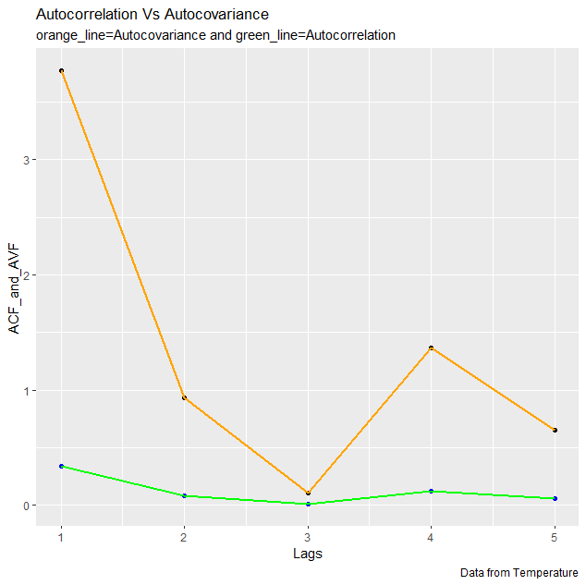

**Plotting the graph using Tableau**

